**Carbon Stocks and Flows Across Flatwoods Landscapes**

Proposal to NCASI - Oct. 4, 2021

Matt Cohen, University of Florida

**Introduction**

Understanding the changing stocks and flows of carbon across forest landscapes is a prerequisite for robust ecosystem service markets. As interest in paying forest landowners for stored C increases, some key knowledge gaps about the C cycle in low-relief wetland-rich plantation landscapes, which dominate the commercial forest landscape of the southeastern US, need to be addressed. The flatwoods of north Florida, where most of the commercial forestry occurs, are characterized by extremely low relief, numerous closed basins, and shallow and temporally dynamic water table conditions. This combination of locally closed depressions and shallow water table depths leads to complex temporal and spatial patterns of surface inundation, and episodic hydrologic connectivity that creates remarkably flashy stream flow exports. These landscape hydrological properties in turn impact when, where, and how the landscape stores and exports carbon. Our goal in this work is to improve our understanding the carbon stocks across these flatwoods landscapes, emphasizing the biomass and soil organic matter pools, and also the dynamic flows of carbon, in the form of vertical gas (CO2 and CH4) and lateral solute (DOC, DIC) fluxes. The rationale for these measurements is to better understand the sequestration potential of flatwoods landscapes, quantify the venues of enhanced storage (e.g., hot-spots), and document periods of enhanced export (e.g., hot-moments). The central hypothesis is that landscape hydrology is the foundational control on when, where and how carbon is stored and lost from the system, implying that hydrologic management can be used as a means to optimize C sequestration as one of several functions that comprise the decision space for land owners. Our focal questions are as follows (Fig. 1):

1. Where in the landscape is soil C stored, and how does that pattern align with extant hydrology?
2. What are the spatial and temporal dynamics of soil gas evasion (CO2 and CH4) and how sensitive are these fluxes to the shifting extent of surface inundation and soil C stocks?
3. What are the dynamics of stream water CO2, CH4, and DOC concentrations and mass export?
4. Where are stream C solutes from, and what fraction of terrestrial production do they represent?

*Figure 1. Daily landscape discharge for a flatwoods river. Inundation patterns (blue, inset maps over a LIDAR DEM) suggest three distinct hydrologic phases: wet-stagnant, dry, and surface connected (Klammler et al. 2020), which control landscape discharge. These stages impact the shape and length of the terrestrial-aquatic interface, and thus the magnitude of C fluxes (arrows at top).*

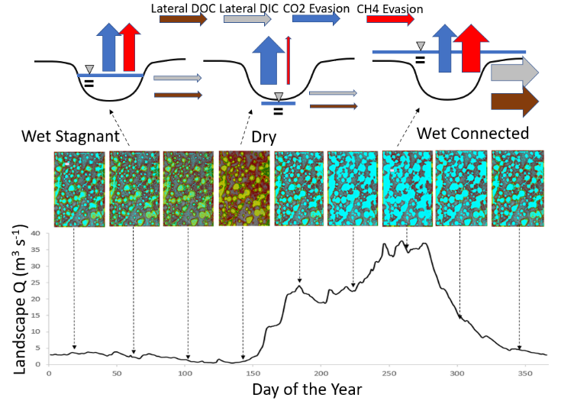

**Methods**

Our measurements will fall into 3 main categories:

1. Spatial OM inventories, focusing of aboveground biomass and soil OM stocks. We will adopt a spatially stratified sampling protocol to sample across the existing hydrologic habitats in the study area, including upland forest, embedded wetlands, and riparian forests. Each selected site will be surveyed using drone-based LIDAR, and sampled for tree density, basal area, leaf area and height, as well as soil OM content in two zones (0 – 10 cm and 10 – 30 cm).
2. Spatiotemporal measurements of soil gas evasion. Using a field IRGA we will replicate measurements at fixed locations across the landscape spanning different hydrologic states of the landscape to quantify when and where gas evasion rates are high, and the conditions that control the partitioning of gas evasion among CO2 and methane.
3. In-stream measurements of dissolved C using sensors and discrete samples. We currently have 10 streams at which we are developing rating curves, and for which we have continuous stage. These are ideal settings to deploy sensors to track temporal dynamics of dissolved organic C, dissolved CO2, and dissolved CH4. We will also obtain monthly samples for more detailed measurements of DOC quality, C isotopes and major element chemistry to provide important context for the gas and organic matter measurements. Since one of our goals is to quantify the provenance of the C in the streams, we will also collect monthly water samples from wells in selected wetlands, newly installed riparian wetland wells, and adjacent upland wells.

Our analyses will allow us to understand stocks and fluxes of C at point, wetland, and landscape scales (Fig. 2), and their respective sensitivities to hydrologic forcing. This will enable improved understanding of existing C stocks are, where hot spots and when hot moments are for mass losses, and hydrological controls that can be adjusted in response to ecosystem service payments.

*Fig. 2 – Predictions at point-, wetland- and wetlandscape-scales (at left) showing (top row) effects of topography on water depth, and water depth controls on gas evasion and point-scale OM storage. At the wetland scale (middle row), elevation variation controls heterogeneity in gas fluxes and solute concentrations. Similar hydrotopographic controls emerge at landscape scales (bottom row) with the added influence of hydrologic connectivity. Simple predictions (dashed lines) contrast with those made with hydrotopographic and OC interactions (solid lines)*

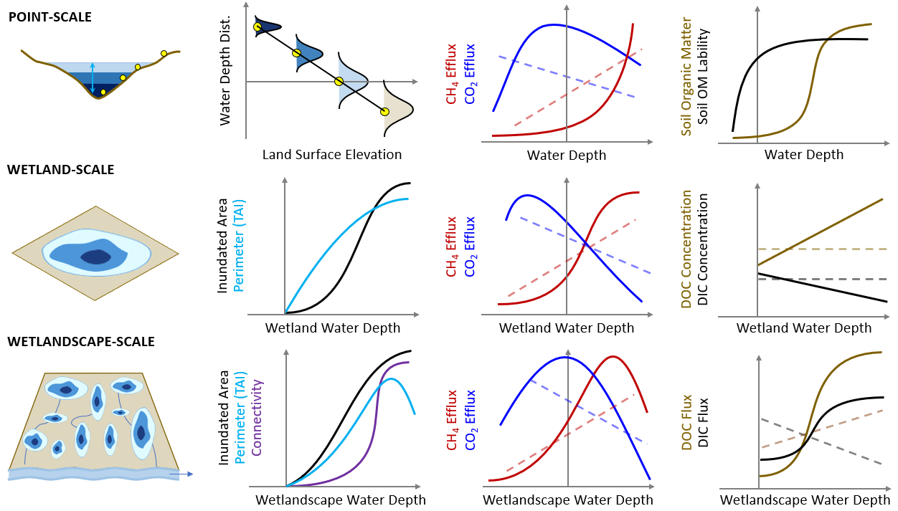

**Study Sites and Leveraged Funding**

This proposed study will take place on the Bradford Forest tract, a 27,000 acre contiguous pine flatwoods site in Bradford County (FL) owned entirely by Rayonier Corporation. A companion project, funded by the Suwanee River Water Management District, has been ongoing at this site for over 1 year now, and has provided an important foundation for this work via the installation of stream flow locations (n = 10), wetland water level locations (n = 52), and rainfall gages (n = 4) across the study site (Fig. 3). At each stream gage (yellow pins in Fig. 3), we have constructed a rating curve to estimate

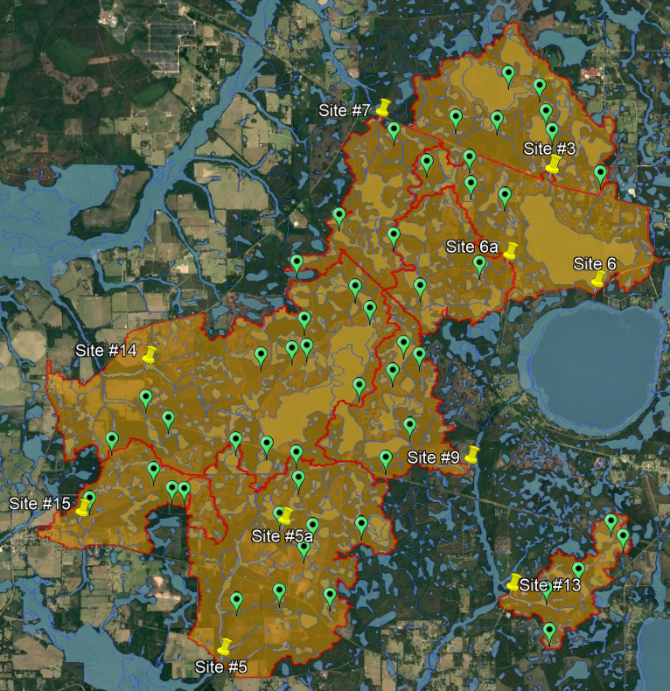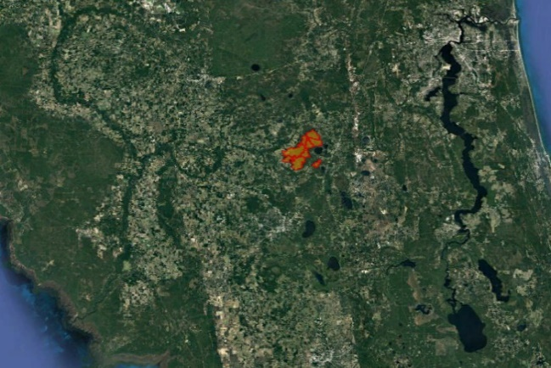

*Fig. 3. The Bradford Forest tract in Bradford County, Florida. Over 27,000 acres of pine flatwoods, owned entirely by Rayonier, has been instrumented with water level recorders in wetlands (green pins), stream flow gages (yellow pins) and rainfall measurement locations. This existing infrastructure is the basis of spatially extensive soil and tree organic matter inventories and stream flow export of C.*

continuous discharge from continuous stage measurements. Each of the wetlands (green pins in Fig. 3) has been analyzed using LIDAR digital elevation models to develop surface inundation and connectivity thresholds. Along with observations of water levels in 52 wetlands across the landscape, distributed among watersheds and stratified by wetland size and proximity to proposed silvicultural operations (harvest, thinning), we aim to reconstruct the landscape hydrology at unprecedented spatial resolution to better understand the hydrologic impacts of pine silvicultural management. This NCASI funding will allow us to leverage this large project ($700,000 for 5 years) to add soil and water carbon stores and fluxes, providing important synergies for both projects. In particular, patterns of where organic matter is stored across this landscape, and when and how carbon is exported, are expected to be strongly linked to the local and watershed hydrology.

**Budget**

The proposed project will occur over 4 years, and consists of direct funding from NCASI to support measurements of carbon stocks and flows across the landscape, leveraged funding from SRWMD for developing the hydrological foundation of our carbon measurements, and proposed funding from the SFI Conservation Grants (due Oct. 2021) to augment the landscape inventory of C stocks with more detailed drone-based measurements. The total budget for this work is $50,000 per year, which will be allocated as follows, including a negotiated IDC rate of 20% less equipment and travel expenses.

|  |  |  |  |  |  |
| --- | --- | --- | --- | --- | --- |
| **Category** | **Year 1** | **Year 2** | **Year 3** | **Year 4** | **Total** |
| Personnel | $27.584 | $31,375 | $32,316 | $33,286 | $124,561 |
| Permanent Equipment | $0 | $0 | $0 | $0 | $0 |
| Travel | $2,500 | $2,500 | $2,500 | $2,500 | $9,983 |
| Materials and Supplies | $12,000 | $7,508 | $6,567 | $5,598 | $31,673 |
| Direct Total | $41,667 | $41,667 | $41,667 | $41,667 | $166,667 |
| Indirect Costs | $7,917 | $7,917 | $7,917 | $7,917 | $31,667 |
| **Total** | **$50,000** | **$50,000** | **$50,000** | **$50,000** | **$200,000** |

**Timeline**

*Year 1*

* Acquisition and installation of sensors to track carbon exports from streams
* Selection and initiation of sites (n = 40) for quarterly soil gas evasion fluxes
* Selection and initiation of sites (n = 400) for soil and vegetation C inventory

*Year 2-4*

* Quarterly gas evasion fluxes
* Continuous water quality measurements
* Models of soil C stocks based on elevation and imputed water table depths
* Models of vegetation C stocks based on satellite imagery
* Models of stream solute export and gas exchange
* Models of soil gas fluxes based on temperature and water levels